Holidays in Egypt Frame by BeetleCraft

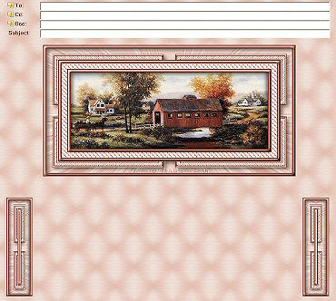
This tutorial is written for Paint Shop Pro 8.

SUPPLIES:
Any image should work.
Plugins needed:
Filter Factory Gallery A - Holidays In Egypt filter
VM Toolbox - Instant Tile filter
VM - Lightsplash filter
Simple

FRAME:
1. Open Image and resize to no larger than 300 in height. Shift/D - close out original image.
2. Select a light color and a dark color from your image.
3. Image/Add Borders - 2 Symmetric using dark color from image
4. Selections/Select All - Selections/Contract by 2.
5. Effects/3D Effects/Cutout using the settings below. Selections/Select None.
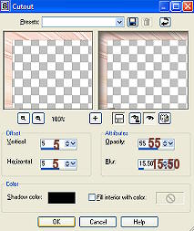
6. Image/Add Borders - 5 Symmetric using light color from image
7. Selections/Select All
8. Selections/Modify/Contract by 5
9. Selections/Invert
10. Effects/3D Effects/Inner Bevel - apply the settings below.
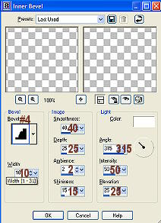
11. Selections/Select None
12. Image/Add Borders - 2 Symmetric using dark color from image
13. Image/Add Borders - 15 Symmetric using light color from image
14. Selections/Select All
15. Selections/Modify/Contract by 15 - Selections/Invert
16. Effects/Plugins/Filter Factory A/Holidays In Egypt using the settings below.
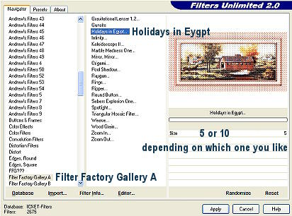
17. Selections/Select None
18. Image/Add borders - 2 - symmetric checked - dark color
19. Image/Add borders - 5 - symmetric checked - light color
20. Selections/Select All
21. Selections/Modify/Contract by 5
22. Selections/Invert
23. Effects/3D Effects/Inner Bevel - apply same settings as #10 above.
24. Image/Add borders - 2 - symmetric checked - dark color
25. Image/Add borders - 30 - symmetric checked - light color
26. Selections/Select All - Selections/Modify/contract 30 - Selections/Invert
27. Effects/Plugins/VM Toolbox/Instant Tile using the default settings.
28. Magic Wand with the below settings.
29. Click on the light color of the border to select.
30. Effects/Plugins/VM/Lightsplash with the below settings.
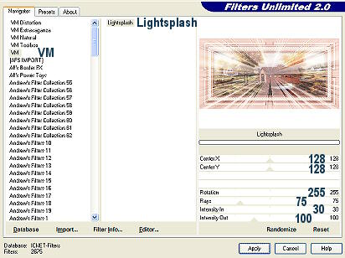
31. Effects/3D Effects/Cutout using the same settings as #5 above. Selections/Select None.
32. Image/Add borders - 2 - symmetric checked - dark color
33. Image/Add borders - 5 - symmetric checked - light color
34. Selections/Select All
35. Selections/Modify/Contract by 5
36. Selections/Invert
37. Effects/3D Effects/Inner Bevel - apply same settings as #10 above.
38. Image/Add borders - 2 - symmetric checked - dark color
39. Add watermark if you want then save as .jpg. Set aside.

SIDEBAR: Part A
1. Selection Tool/Rectangle and select from the top left corner over to right for about 44-45 pixels. This should select it in the middle of the second set of borders you added. See example below.
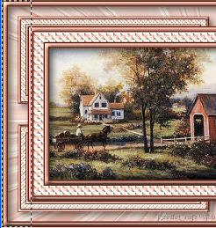
2. Paste as new image.
3. Image/Canvas Size - double the width but keep the same height.. make sure you hit the
arrow toggle pointing to the left. See example below.
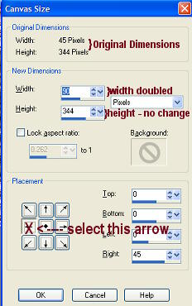
4. Layers/Duplicate
5. Image/Mirror
6. Layers/Merge/Merge all flatten
7. Image/Resize : 75% Bicubic - all layers checked
8. Save as .jpg
9. Set aside.

BACKGROUND:
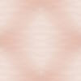
1. New image - Transparent - 100 x 100
2. Selections/Select All
3. Go to sideborder you have setting aside - Edit/Copy
4. Back to your new image and Edit/Paste/Into Selection - Selections/Select None
5. Adjust/Blur/Gaussian Blur using 10.00 for the radius.
6. Adjust/Blur/Motion Blur using 90 for the angle and 50 for the strength.
7. Effects/Plugins/VM/Lightsplash with the below settings.
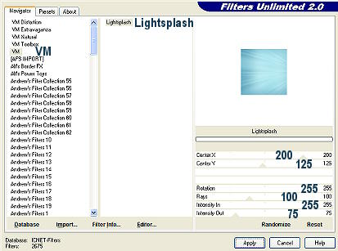
8. Effects/Plugins/Simple/4 Way Average
9. Effects/Plugins/Simple/Quick Tile
10. Save as .jpg

Put together in Letter Creator for Incredimail or any other email program as you'd like or use my example at the top on how to position the images.

Tutorial Written by KaEfEr of:


